In this project, I will be analysing shot logs from 2013-2019 in the NBA. I have obtained ‘Play by Play’ data for every game between 2013-2019. Every shot taken in the game is recorded, with a few other details; for example, who took the shot, shot type, whether it was made or missed, how many points its worth, x and y locations, etc.

Here is a snapshot of the data:

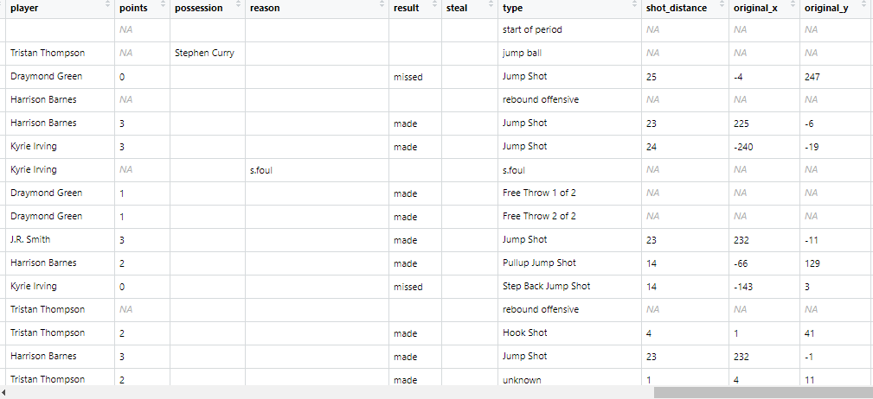

The ‘original_x’ and ‘original_y’ columns allow us to visualize where a select group of shots are taken from. It is useful because we can visually represent each row in the dataset. Here is a plot that shows all made and missed shots in one game:

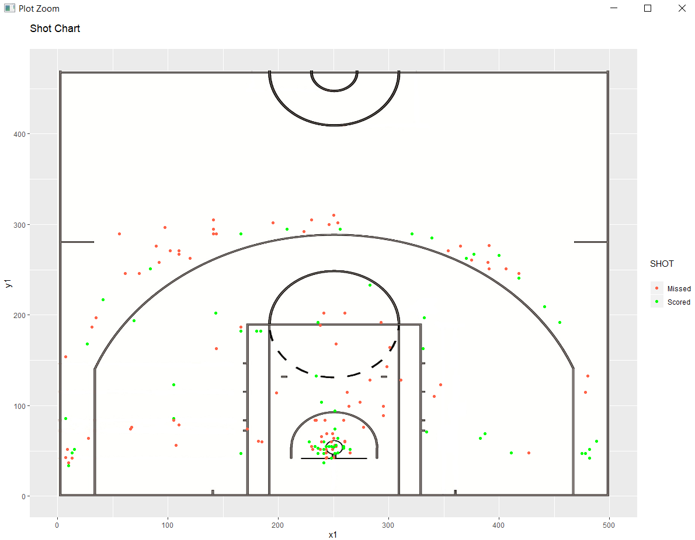

I have also obtained the data for per-game shot attempts. That is, the average shot attempts per game, for each player. This data was scraped from stats.nba.com

Here is a snapshot of the dataset sorted by ‘FGA’ (shots attempted per game):

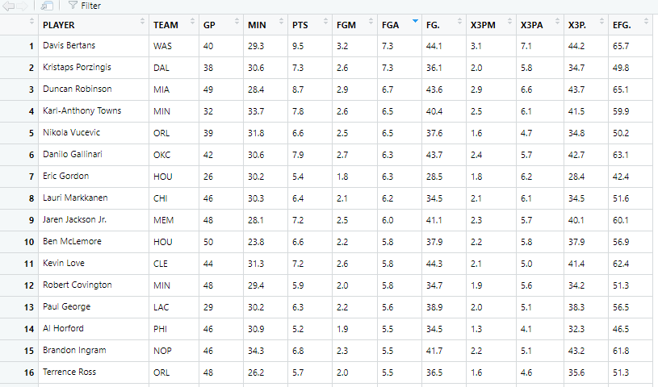

The NBA has seen an upward trend of 3-point shots attempted over the last few years. I will make it a priority in this project to analyse the trends in 3-point shooting over the years. The second dataset will represent population, while one game can be represented as a sample.

We can break down shooting into two types: ‘Catch and Shoot’, and ‘Off the Dribble’. Although we have a ‘shot_type’ column in the first dataset, it does not directly infer that a shot may definitely be one of the two types. In the second dataset, we have the average ‘Catch and Shoot’, and ‘Off the Dribble’ shots taken by each player per game. Using this data, we can predict what each shot type is, and analyse how it has changed over the years.